Clone-42

A First-person Action Horror Game

* Horror Game fights monsters (Magic)
* Goal to Save Something (Clone, Item, Object)
* Environment and Enemies are Horror.
* Sounds Horror
* Health Bar,
* Mana/Bullets/Stamina

# Project Overview

## High Concept and Mockup

Provide a **brief 1-2 sentence description** of your game, the main game loop, and followed by your **mockup** visualizing what the player will see when they play your game.

You’re “Clone-42” an experiment whose set out to retrieve intel from abandoned sites, the player will wander through the map, fighting enemies and pushing past obstacles to achieve the task provided. Death is inevitable but with each clone iteration, your understanding of the map, tasks and abilities grow.

*Retaining knowledge marks, the player learning over time*

[Reference Mockup]

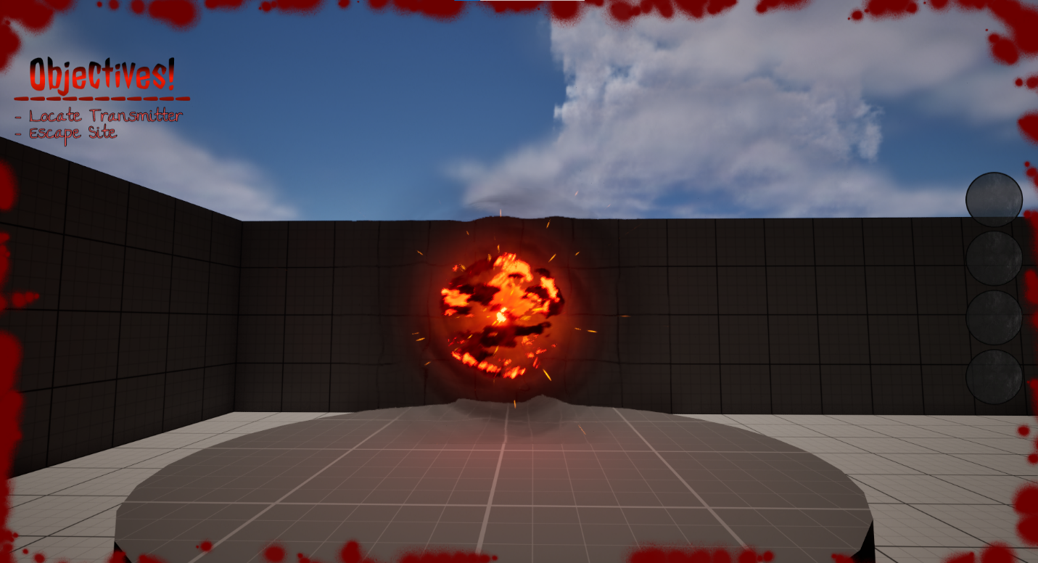

## Character

Describe the **character** that the player will be playing as. If the player does not control a particular character, describe the types of characters that the player interacts with during gameplay.

A humanoid entity known as “Clone-42” is controlled by the player, it’s designed to retain knowledge over previous iterations and is initially limited to basic human capabilities. “Clone-42” learns and adapts over time, gradually developing new skills to engage with the challenges faced during missions.

These missions undertaken by “Clone-42" present supernatural phenomena, this causes the character to learn abilities that exceed human limitations allowing them to overcome obstacles otherwise seemed impossible.

## Camera

Describe the **perspective** that the game will be played from.

The game will be experienced through the character's eyes, the first-person camera will allow the player to experience the game as the “Clone-42” does and immerse themselves in the world of horror. Incorporating mechanics like flashlight/night vision become much easier and more practical to implement.

{Other Idea} Camera Perspective as a camera on the entity.

Pros:

* Time-Limited Battery for Camera, adding urgency and strategy (Night Vision included)
* Detached but still engaging and observing from an objective standpoint.

Cons:

* Might deduct immersion and make player feel too detached.
* Extra Effort and requirements to meet.

// Possible Description // WIP

The player will observe through a camera placed as "Clone-42"'s eyes, giving them a unique perspective to be controlling the game from. The perspective provides immersion in a new form, giving control but also detaching them from the player a bit to feel less in control. Additional features like night vision can be included and nerfed with its consuming battery life of the camera.

## Controls

Describe the **controls** that the player will use to interact with the game.

The player will move around the map using basic (WASD) along with the ability to crouch and walk faster or sprint. There will be no jumping mechanic yet, and maybe changed for progression or after testing. Moving the camera is as simple as moving around your mouse and the players’ movement are relative to the camera perspective.

Main controls consist of interacting with objects, toggling personal lighting (Flashlight/Night Vision) and accessing items in the players inventory with (1,2,3,4). Additional controls will include abilities that may be implemented and learnt as the progression of the game.

All Current Known Controls:

Movement:

* Move forward, left, right, back (WASD)
* Crouching (Left Control)
* Sprint/Fast Walk (Shift)

Main Controls:

* Inventory (1,2,3,4)
* Night Vision/Flashlight (F)
* Interact (E)

## Game States

Each **section or phase** of your game, such as a main menu, a battle, overworld navigation, or credits screen, should be described below. Each section should be accompanied by a **UI wireframe**, indicating **what UI elements are needed** and **their positions** on the screen.

You will need at least the following: a **Splash Screen**, a **Main Menu**, and a **Gameplay** screen; sections for each are added below. If your game has more, please add new sections for them.

## Splash Screen

When first loading the game, you will be introduced by our title screen for “Clone-42” indicating you’re in the game. Proceeding that will be a warning splash screen for audience who may be sensitive to the following game, the main menu will be shown once the player has read the warning (using player input).

## Main Menu

The main menu will equip the player with options to play the game, exit the game, or view the game instructions. Each one of these inputs will bring the player to a new screen involving what they clicked.

## Instructions Menu

This interface will show the player all main goals and controls for the game, how they are supposed to play and win the game. Although it might not cover all mechanics it provides a strong base for them to work off and develop throughout the game.

## Gameplay

The player will be given a few HUD items to show relevant information used within the game:

* Current Objective (Top Left of Screen)
* Inventory Slots (Middle Right of Screen)
* Health (Blood Border Effect)

Some of these might become smaller or retractable due to horror game, needing to be as immersive as possible which means less information on the screen.

# Roadmap

Provide an **overview** of the time taken to create this project and **the objectives that will be completed** by each section of time. (This doesn’t need to be super detailed – bullet points and lists will do fine)

|  |  |
| --- | --- |
| **Week** | **Objectives** |
| 1 | * Basic Main Menu Mechanics * Solid Framework for Game Map * Objective/Win State * Player Mechanics & Controls * Enemies & Player Health (Player/Enemy Interactions) |
| 2 | * Splash Screens * Main Menu/In-Game Menu * Touches on Map & Atmosphere * Other Objective (For Variety) * Sound Effects |

With spare time and the other objectives completed I would like to touch up on all the environmentally based aspects if needed, creating immersion and true horror. Additionally adding more functionality to the game like abilities or a more solid game loop. Possibly using more levels and objectives to create replay ability.

Overall, just final touches to the game, making it run smoothly and all the functionality is well defined for our player.

# Credits

List each member of the team that will be working on this project. Each person should have their name and title clearly displayed. This applies, even if working alone.

Van-Jordan Allen – Game Programmer

## Third-Party Works

If you are using any assets or plugins, please list them below.

Comment Plugins (Auto Size)